ELECTRONIC ASSIGNMENT COVERSHEET | 

Student Number: | 35517678
Surname: | New
Given name: | Wei Nern
Email: | 35517678@student.murdoch.edu.au
Unit Code: | ICT373
Unit name: | Software Architecture
Enrolment mode: | Internal
Date: | 18/7/2025
Assignment number:
Assignment name:
Tutor: | Andy Lee

Student’s Declaration:
- Except where indicated, the work I am submitting in this assignment is my own work and has not been submitted for assessment in another unit.
- This submission complies with Murdoch University's academic integrity commitments. I am aware that information about plagiarism and associated penalties can be found at http://our.murdoch.edu.au/Educational-technologies/Academic-integrity/. If I have any doubts or queries about this, I am further aware that I can contact my Unit Coordinator prior to submitting the assignment.
- I acknowledge that the assessor of this assignment may, for the purpose of assessing this assignment:
  - reproduce this assignment and provide a copy to another academic staff member; and/or
  - submit a copy of this assignment to a plagiarism-checking service. This web-based service may retain a copy of this work for the sole purpose of subsequent plagiarism checking, but has a legal agreement with the University that it will not share or reproduce it in any form.
- I have retained a copy of this assignment.
- I will retain a copy of the notification of receipt of this assignment. If you have not received a receipt within three days, please check with your Unit Coordinator.

I am aware that I am making this declaration by submitting this document electronically and by using my Murdoch ID and password it is deemed equivalent to executing this declaration with my written signature.
Optional Comments to Tutor:
e.g. If this is a group assignment, list group members here

If you can, please insert this completed form into the body of each assignment you submit. Follow the instructions in the Unit Information and Learning Guide about how to submit your file(s) and how to name them, so the Unit Coordinator knows whose work it is.
Start your assignment on the next page.

Magazine
Subscription Management GUI

Manage customers, subscriptions, and publications easily with an intuitive graphical interface that supports adding, editing, and deleting records.

Author: New Wei Nern
Murdoch Student ID: 35517678
Date: 15/7/2025
Student Note: When the project is built, the data of customer and publication will be stored in target folder. The data will not update the files stored in src.
Files: Please refer to page 5 for the list of files.

Contents
List of Files 5
User Guide 8
Requirement / Specification 10
Input Conditions 11
Output Conditions 11
Structure / Design 12
Low Class Diagram 12
High Class Diagram 13
State Transition Diagram 15
Program Design 16
Class Responsibilities 17
Pseudocode 21
CustomerModel Method 21
PopupController.initialize Method 21
MainController.saveDAT Method 21

List of Files

Files | Summary
App.java | The application class for the Magazine Subscription Management System.
controllers/MainController.java | Main entry point of the application.
controllers/customer/AssociateController.java | Display the associates of a paying customer.
controllers/customer/BillingController.java | Display the billing information for a paying customer.
controllers/customer/CustomerController.java | Display the customer page.
controllers/customer/PopupController.java | Display customer-related popups such as edit, add, and view.
controllers/customer/SelectionController.java | Display magazine / supplement selection popup.
controllers/customer/SubscriptionController.java | Display a list of customer subscription in table view.
controllers/publication/CustomerController.java | Display a list of customer in table view.
controllers/publication /PopupController.java | Display publication-related popups such as edit, add, and view.
controllers/publication /PublicationController.java | Display the publication page.
customers/AssociateCustomer.java | Represents an associate customer.
customers/PayingCustomer.java | Represents a paying customer. The paying customer is allowed to pay for a subscription for someone and itself.
customers/Customer.java | A base class for all customers, with common attributes and behaviours.
models/CustomerModel.java | A model for storing customers in the system.
models/PublicationModel.java | A model for storing publications in the system.
payment/CreditCard.java | Represents a credit card. The credit card class contains customer ID, card number, and expiry date.
payment/DirectDebit.java | Represents a direct debit. The direct debit class contains customer ID, bank name, and account number.
payment/Method.java | An interface to represent different payment methods.
publications/Magazine.java | Represents a magazine.
publications/Subscription.java | A base class for all subscriptions, with common attributes and behaviours.
publications/Supplement.java | Represents a supplement.
utils/Address.java | Represents an address.
utils/BaseController.java | A base controller class for handling common functionalities across controllers.
utils/BaseModel.java | A base model class for managing data in the system.
utils/Bundler.java | A utility class for bundling publications and customers together for serialization.
utils/CustomerSubscription.java | Represents a subscription of a customer to a publication.
utils/Identity.java | An interface for classes that contain the implementation of getId method.
utils/Validator.java | A functional interface for validating data.

User Guide

Before running ICT373_New_Wei_Nern_Assignment-2 project, ensure you have the following programs installed on your system:

- Java Development Kit (JDK) 23.0.1
  - Download the JDK from the official Oracle Archive website
  - Install the JDK and ensure Java is set up by running java -version in the CMD.
- Apache NetBeans IDE 24
  - Download Apache NetBeans from the official Apache NetBeans website
  - Install NetBeans and ensure it detects the installed JDK

To run the project:
- Extract the zip file “ICT373_New_Wei_Nern_Assignment2.zip” to NetBeansProjects folder 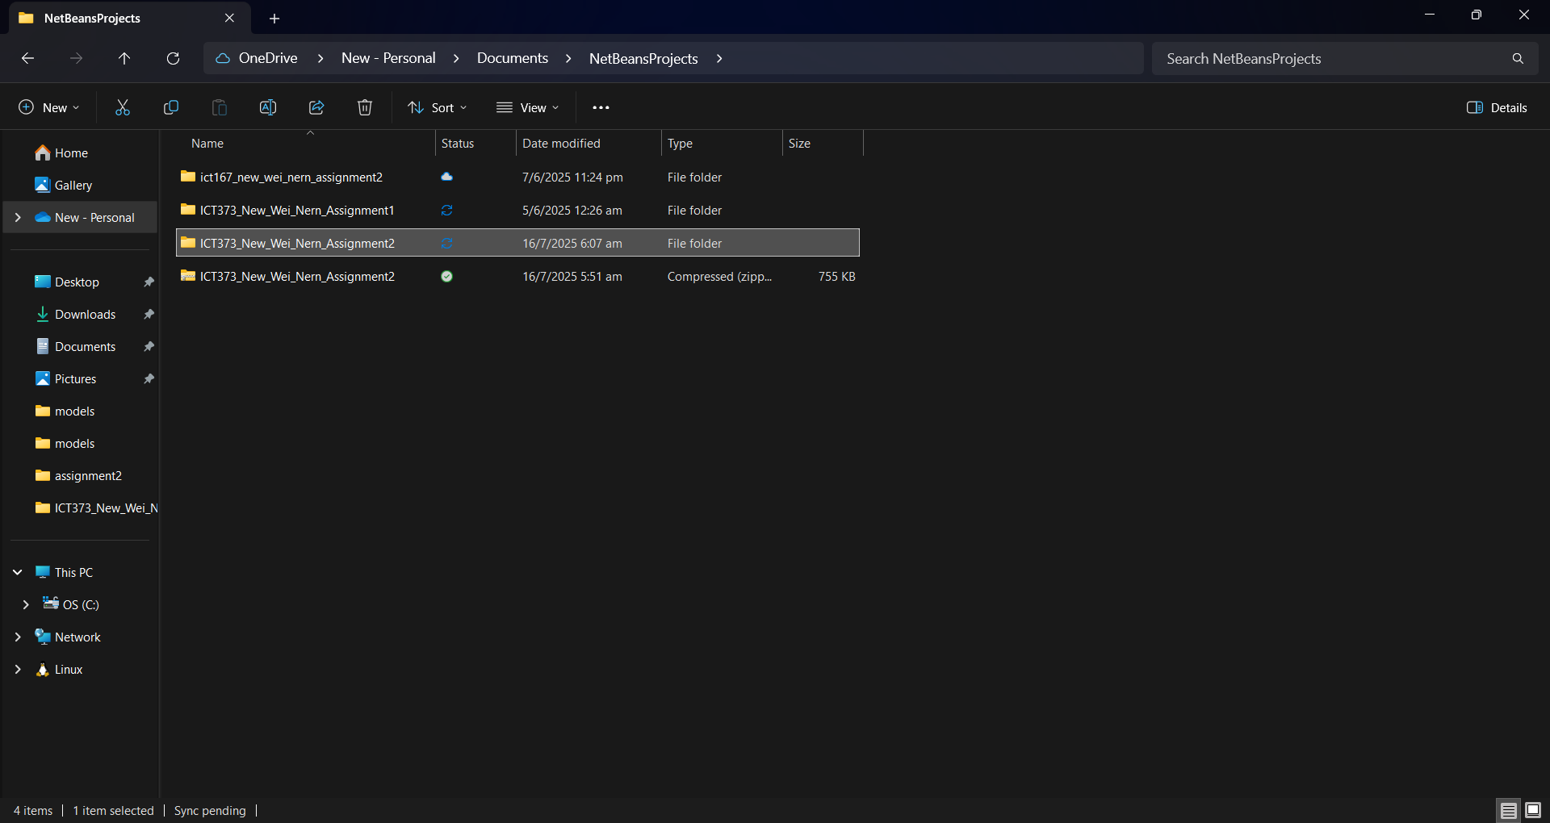
- Open Apache NetBeans IDE 24
- Click on File, Open Project
- Open “ICT373_New_Wei_Nern_Assignment2” 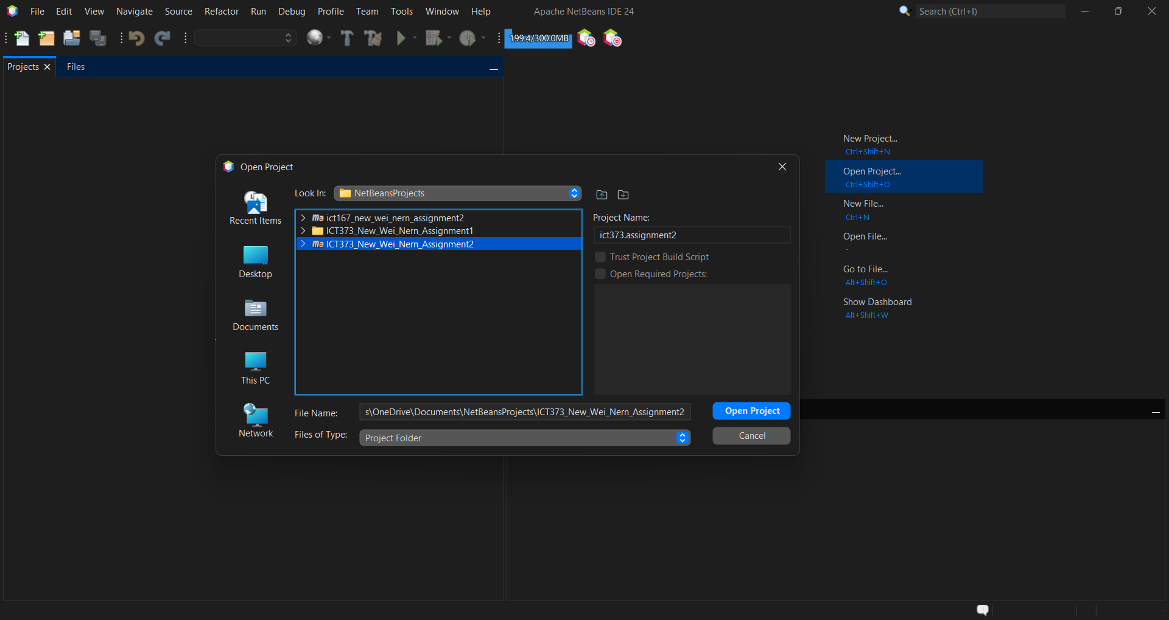

- Click the Run button in the toolbar or press F6 to run the project

Requirement / Specification

The Magazine Subscription Management System GUI replaces the previous CLI, offering a more user-friendly and efficient experience. It retains the core features of the original system, including the ability to add, remove, and edit customers and publications, as well as assign magazines or supplements to customers.

Customers are classified into two types: Paying and Associate. When managing customers through the administrative interface, associate profiles display basic tabs such as Profile, Address, and Subscription. In contrast, paying customers include additional administrative tabs, including Payment Information, Associates, and Billing.

Administrators can remove an associate from a paying customer, which immediately deactivates the associate's subscription. Only associates linked to an active paying customer hold valid subscriptions. Similarly, deleting a paying customer automatically deactivates the subscriptions of all their associated customers.

In addition to managing customers, the GUI allows administrators to assign and remove subscriptions, including the magazine and its related supplements. Previously, customers could subscribe to the same supplements and magazine multiple times; however, this behaviour has since been disabled to prevent redundant subscriptions.

Unlike the previous version, this version integrates persistent data storage using Java serialization, enabling the saving and loading of data. Additionally, a unified master list has been implemented to consolidate both customers and publications into a single structure.

Input Conditions
- Magazine Subscription – Customer must subscribe to the main magazine before subscribing to its supplements.
- No Duplicated Subscriptions – Customer cannot subscribe to the same publication more than once.
- Payer for the Associate – An associate customer may have zero or one paying customer.
- Paying Customer Deletion – Deleting a paying customer will deactivate all associated customers that are registered to the paying customer.
- Associate Customer Deletion – When an associate is deleted, the link to the paying customer is also removed.

Output Conditions
- Publication and Customer – Publications and customers are displayed in table view.
- Master list – A master list containing both publications and customers is saved as a single unit.
- View, Edit, and Add – All three actions open a popup with tabs tailored to different customer and publication types.
- Billing – The total subscription cost, including associated customers, is displayed in the paying customer’s billing tab.
- Inactive Payer – Associate customer without a designated paying customer will have their subscriptions marked inactive.

Structure / Design

Low Class Diagram
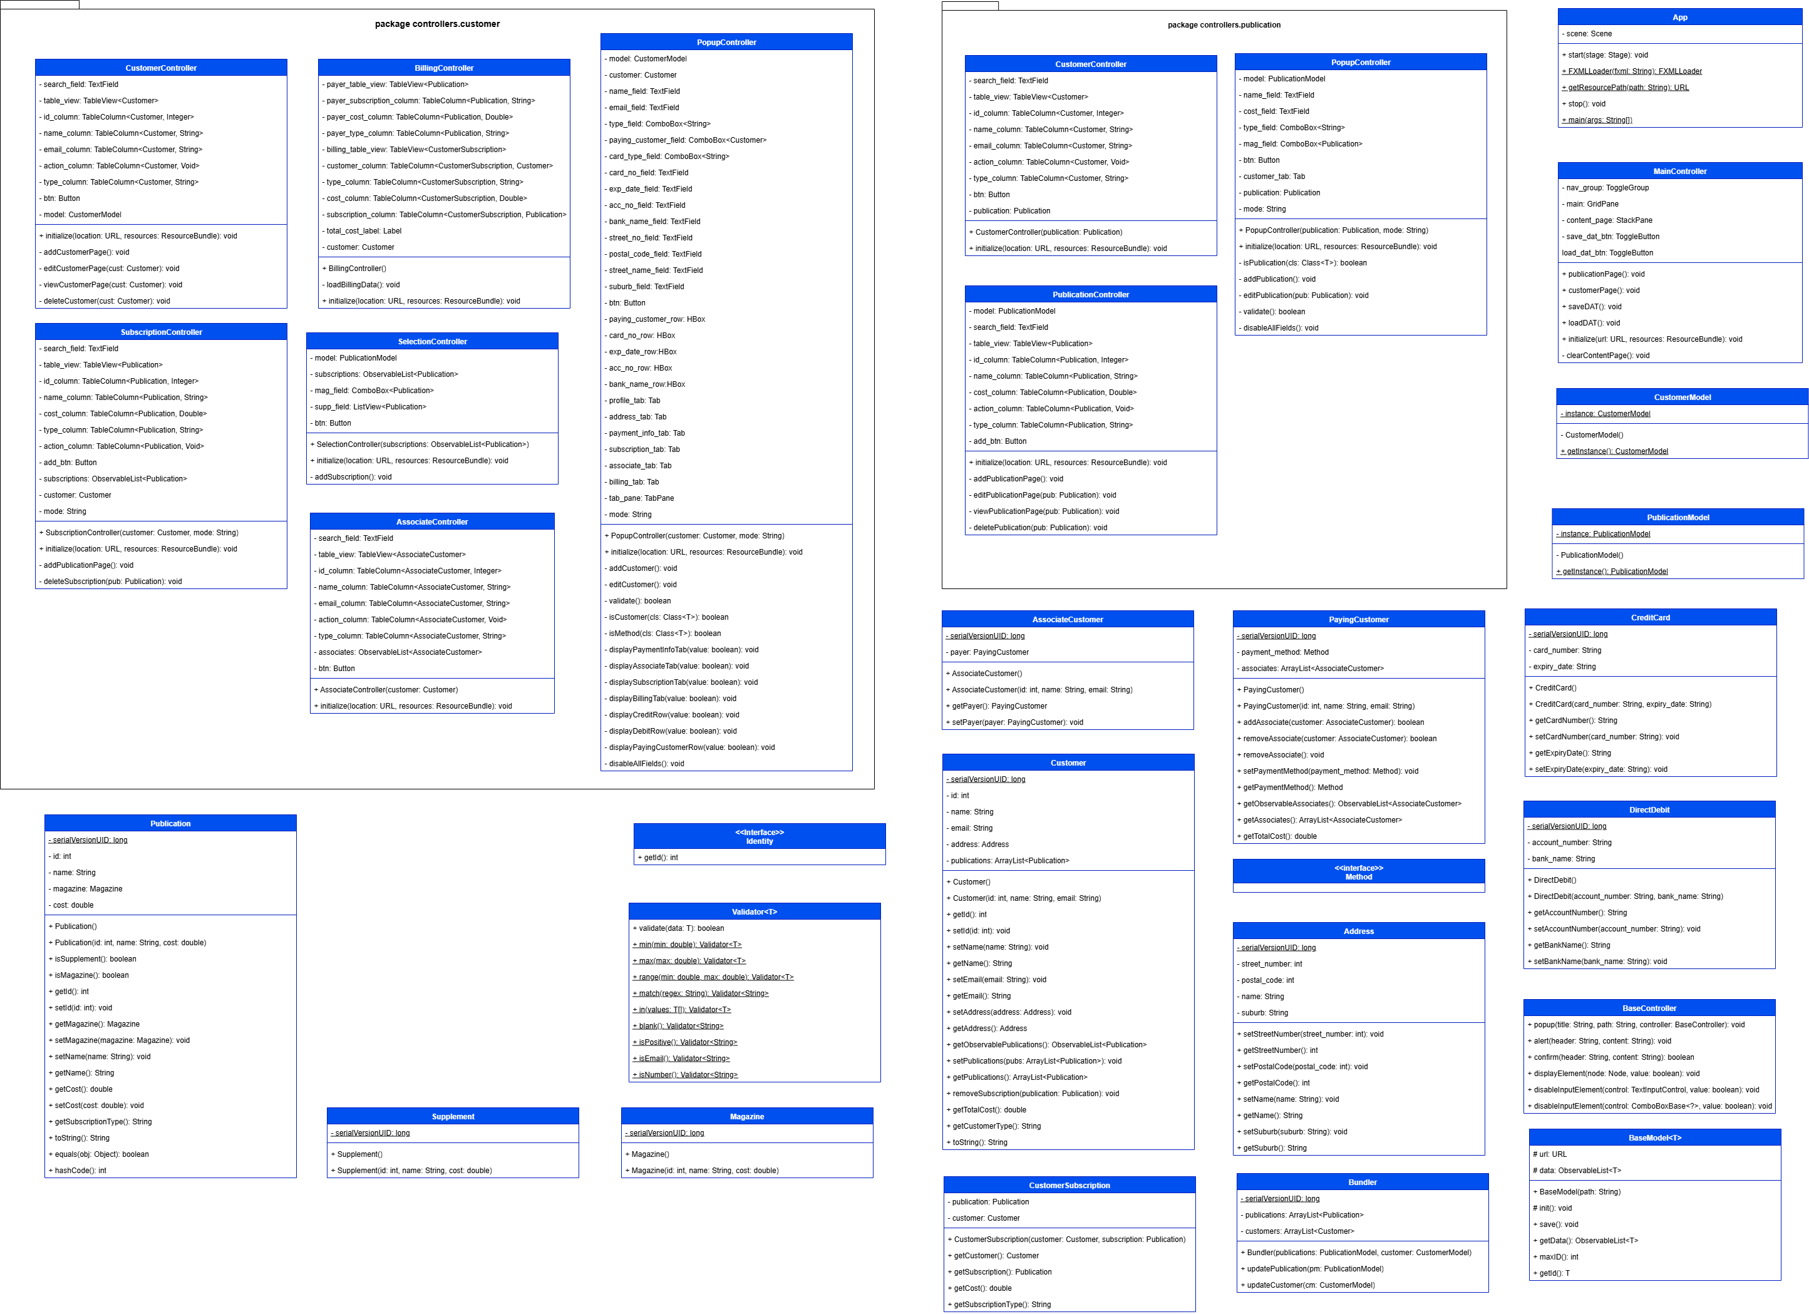

High Class Diagram
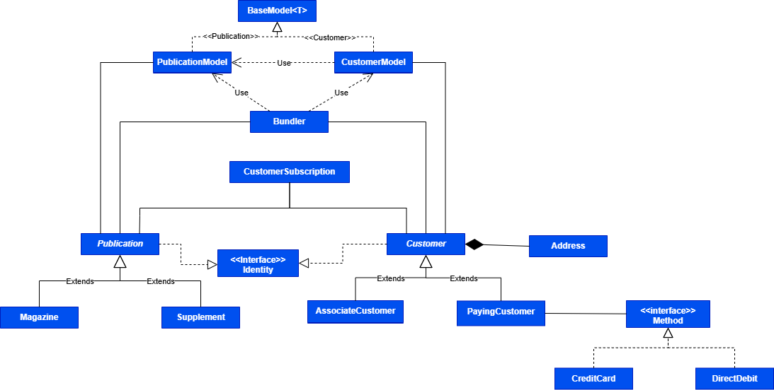

The diagram focuses on the core model. Controller classes and their associations have been omitted from this overview to preserve clarity.
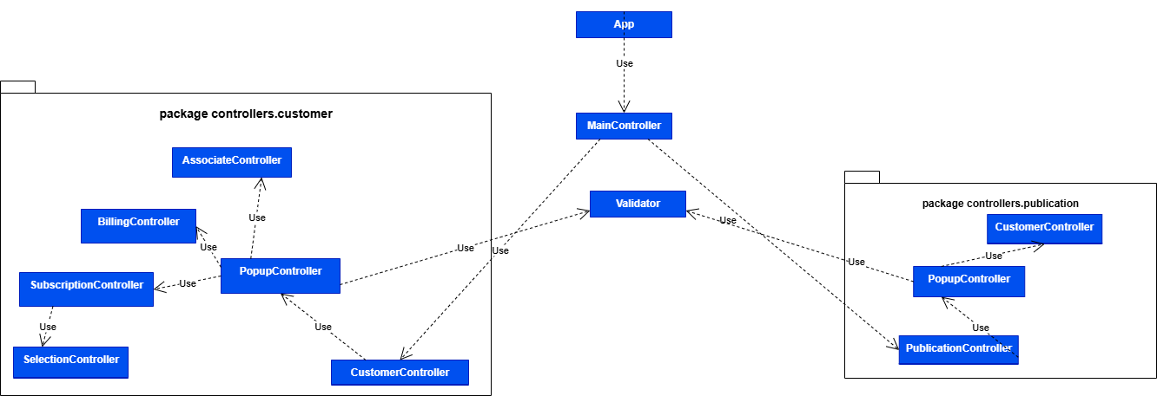

The secondary diagram illustrates the interrelationships between controller classes. While all controllers inherit from a common BaseController, this superclass has been intentionally omitted to reduce diagram clutter, as it does not contribute to the domain-specific interactions depicted.
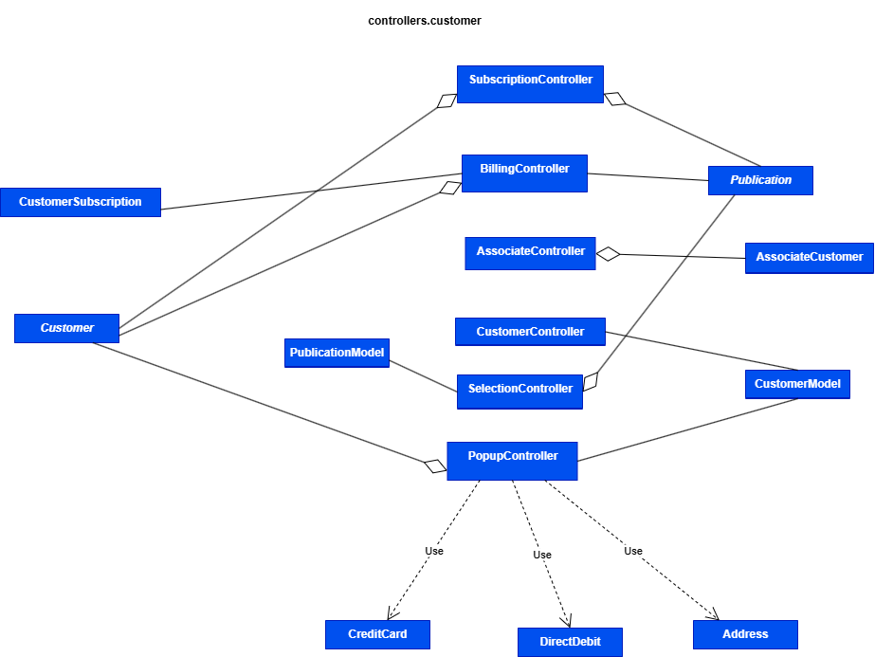

The third diagram illustrates the structure of controllers.customer package. Most of the controllers within this package – such as PopupController, SubscriptionController, BillingController, AssociateController, and SelectionController – are not accessible externally. The only accessible class is CustomerController, which serves as the entry point to this module.

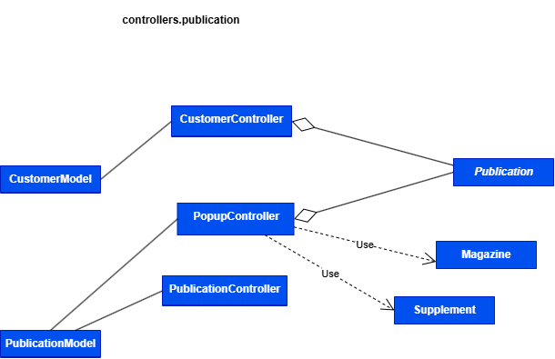

The fourth diagram illustrates the structure of controllers.publication package. Most of the controllers within this package – such as PopupController and CustomerController – are not accessible externally. The only accessible class is PublicationController, which serves as the entry point to this module.

State Transition Diagram

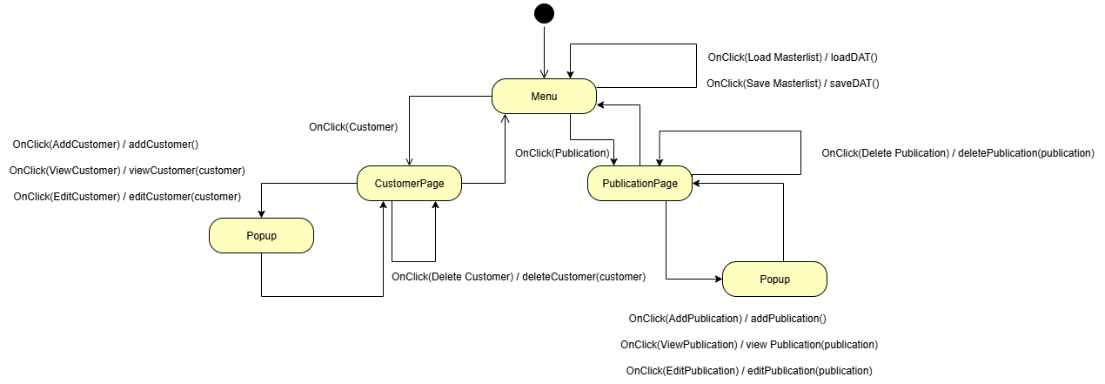
The State Transition Diagram illustrates the behaviour of the system. It begins at the Main Menu, where a default page is selected. From there, the user can transition to either the Customer or Publication page. Each page supports operations such as adding, editing, viewing, and deleting records. For editing, adding, and viewing, a reusable popup window is employed. Additional actions, such as saving or loading the master list, are available if the user chooses to persist or retrieve the current system state.

Program Design
To facilitate communications between data, pages, and views effectively, I employ Model-View-Controller to manage the program. This encapsulates the program’s data and business logic; the View, handles all the graphical representation and interaction layer; the Controller, orchestrates the flow of data between the Model and View, and finally, the Model which handles the data storage.

The program further reinforces encapsulation and reduces coupling by making most controllers inaccessible from outside the package. By internalizing their access, the system ensures that external modules cannot manipulate internal state or logic. Within the controller package, only a single controller is exposed externally, serving as the designated access point for interaction with the rest of the system.

All classes are designed with the S.O.L.I.D Principle in mind, ensuring that the system remains extensible and promotes code reuse. An example of that is BaseModel<T> class, which serves as a template for handling model-specific logic and enabling shared behaviour across classes such as CustomerModel and PublicationModel. To enforce that abstract classes implement a getId method, the template type T is constrained to extend an interface.

As the volume of data expands, both PublicationModel and CustomerModel are implemented using the singleton pattern. This design choice ensures only one instance of each model exists, thereby preventing redundant data initialization and conserving system resources and reducing memory overhead. To complement this, hydration is employed to restore an object’s state from serialized data. This mechanism enables objects to reflect their updated state immediately.

UI/UX Design

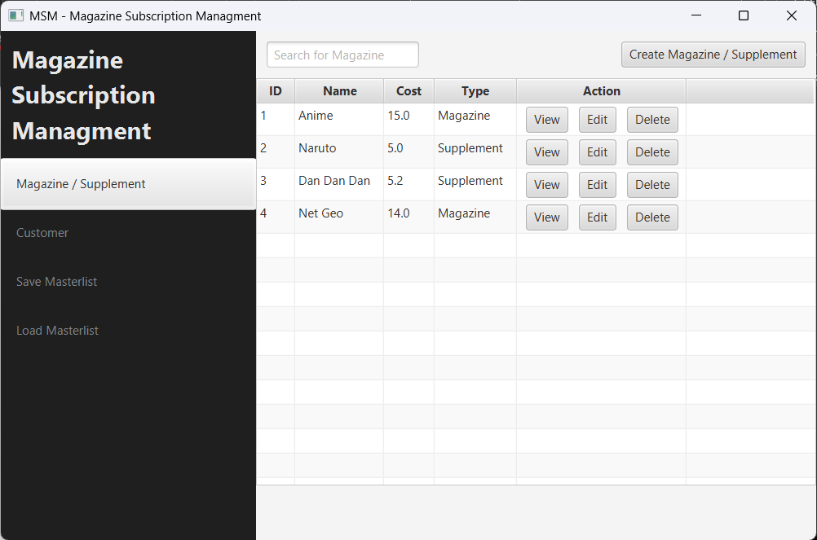
Figure 1 Shows the default page of Magazine Subscription Management.

The UI design leverages JavaFX elements with minimal modifications to the default style, ensuring a clean and consistent look across pages and popups while accelerating development. Accurate rendering of text fields and tabs is paramount, as rows previously accessible to paying customers must remain restricted for associate customers. Failure to enforce these distinctions could lead to undesirable UI/UX outcomes and potentially violate established business rules.

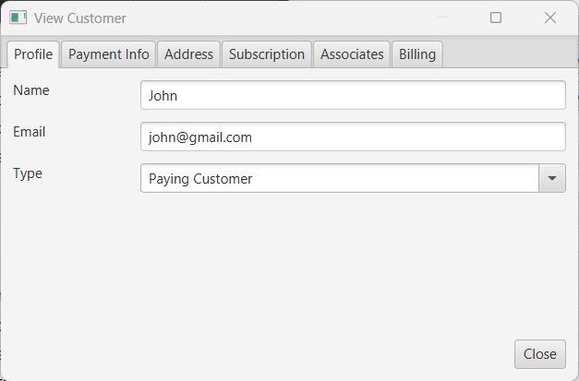
Figure 2 shows the Paying Customer interface

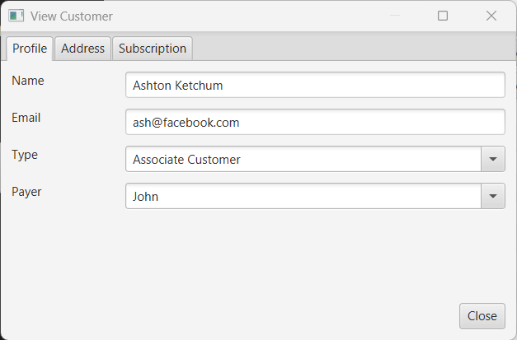
Figure 3 Shows the Associate Customer interface

The TableView serves as a central component for data presentation by offering a structured and interactive way to display publications and customers. To maintain consistency between each pages, the FXML containing the TableView elements are reused. This approach streamlines development while reducing the need for maintenance.

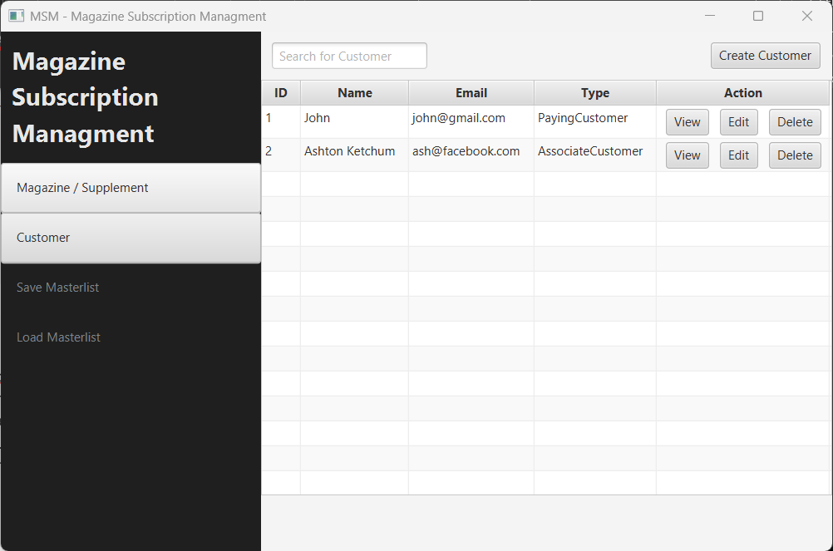
Figure 4 The table view in Customer Page

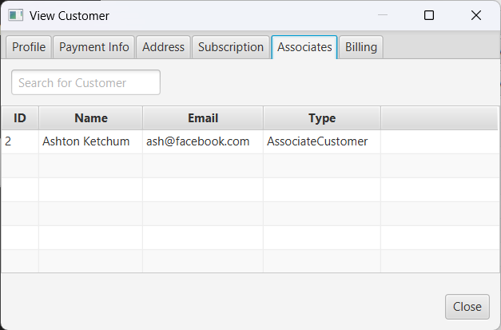
Figure 5 The same table view from a customer tab called "Associates"

Lastly, the feedback for each interaction is essential in guiding the user through the application’s workflow. Whether it is through visual cues like button highlights, popup confirmations, focusing on incorrect fields, or error messages, the UI provides responses to user actions. This reinforces user confidence and reduces the likelihood of mistakes and ultimately enhances the overall user experience.

Class Responsibilities
Class Name | Purpose | Methods
App | The entry point of the application for the Magazine Subscription Management system. | start(),  FXMLLoader(String),  getResourcePath(String),  stop(),  main(String[])
controllers
MainController | Controller for the main application that handles displaying of pages and saving / loading of the master list. | publicationPage(),  customerPage(),  saveDAT(),  loadDAT(),  initialize(URL, ResourceBundle),  clearContentPage()
controllers.customer
AssociateController | Display the associates of a paying customer. | initialize(URL, ResourceBundle)
BillingController | Display the billing information. | initialize(URL, ResourceBundle),  loadBillingData()
CustomerController | Display customer data and actions.  This class is publicly accessible outside of the package. | initialize(URL, ResourceBundle),  addCustomerPage(),  editCustomerPage(Customer),  viewCustomerPage(Customer),  deleteCustomer(Customer)
PopupController | Display popup with customer detail ranging from associates, billing, address, payment method, and profile.  This class incorporates all the controller within the package apart from CustomerController. | initialize(URL, ResourceBundle),  addCustomer(),  editCustomer(),  validate(),  isCustomer(Class<T>),  isMethod(Class<T>),  displayPaymentInfoTab(bool),  displayAssociateTab(bool),  displaySubscriptionTab(bool),  displayBillingTab(bool),  displayCreditRow(bool),  displayDebitRow(bool),  displayPayingCustomerRow(bool),  disableAllFields()
SelectionController | Display selection of magazines and supplements to choose from. If a publication is subscribed, the program will ignore it. | initialize(URL, ResourceBundle),  addSubscription()
SubscriptionController | Display customer’s subscriptions. | initialize(URL, ResourceBundle),  addPublicationPage(),  deleteSubscription()
controllers.publication
CustomerController | Display all the customers that are currently subscribed to the publication. | initialize(URL, ResourceBundle),  addPublicationPage(),  deleteSubscription(Publication)
PopupController | Display popup with publication detail such as info and customer’s subscription.  This class incorporates all the controller within the package apart from PublicationController. | initialize(URL, ResourceBundle),  isPublication(Class<T>),  addPublication(),  editPublication(Publication),  validate(),  disableAllFields()
PublicationController | Display publications and actions.  This class is publicly accessible outside of the package. | initialize(URL, ResourceBundle),  addPublicationPage(),  editPublicationPage(Publication),  viewPublicationPage(Publication),  deletePublication(Publication)
models
CustomerModel | Model for storing customers, saving, and loading customer.dat file. | getInstance()
PublicationModel | Model for storing publications, saving, and loading publication.dat file. | getInstance()
customers
AssociateCustomer | Represent an associate customer. | getPayer(),  setPayer(PayingCustomer)
Customer | Represent a customer. | getId(),  setId(),  setName(String),  getName(),  setEmail(String),  getEmail(),  setAddress(Address),  getAddress(),  getObservablePublications(),  setPublications(ArrayList<Publication>),  getPublications(),  removeSubscription(Publication),  getTotalCost(),  getCustomerType(),  toString()
PayingCustomer | Represent a paying customer. | addAssociate(AssociateCustomer),  removeAssociate(AssociateCustomer),  removeAssociate(),  setPaymentMethod(Method),  getPaymentMethod(),  getObservableAssociates(),  getAssociates(),  getTotalCost()
payment
CreditCard | Represent a credit card payment method. | getCardNumber(),  setCardNumber(String),  getExpiryDate(),  setExpiryDate(String)
DirectDebit | Represent a direct debit payment method. | getAccountNumber(),  setAccountNumber(String),  getBankName(),  setBankName(String)
Method | An interface that represents a payment method.
publications
Magazine | Represent a magazine.
Supplement | Represent a supplement.
Publication | Represents a publication which can either be a magazine or a supplement. | isSupplement(),  isMagazine(),  getId(),  setId(int),  getMagazine(),  setMagazine(Magazine),  getName(),  setName(String),  getCost(),  setCost(double),  getSubscriptionType(),  toString(),  equals(Object),  hashCode()
utils
Address | Represent a customer’s address. | setStreetNumber(int),  getStreetNumber(),  setPostalCode(int),  getPostalCode(),  setName(String),  getName(),  setSuburb(String),  getSuburb()
BaseController | The base controller for handling common functionalities across controllers.  All Controllers must inherit BaseController. | popup(String, String, BaseController),  alert(String, String),  displayElement(Node, bool),  disableInputElement(TextInputControl, bool),  displayInputElement(ComboBoxBase<?>, bool)
BaseModel | The base model class for managing data in the system.  The base model allows a single data type to be utilized. | init(),  save(),  getData(),  maxID(),  getId(int)
Bundler | Bundles publications and customers together. | updatePublication(PublicationModel),  updateCustomer(CustomerModel)
CustomerSubscription | Represent a subscription made by a customer. | getCustomer(),  getSubscription(),  getCost(),  getSubscriptionType()
Identity | An interface that enforces the inclusion of getId() method.
Validator | A validator that validates value. | validate(),  min(double),  max(double),  range(double, double),  match(String),  in(T…),  blank(),  isPositive(),  isEmail(),  isNumber()

Pseudocode
Below are three of the codes which are deemed unique / complicated.

CustomerModel Method
Function CustomerModel()
super("customer.dat");
p_model = PublicationModel.instance

for cust : customers
customer_subs = cust.publications

for sub : customer_subs
sub = p_model.Id(sub.Id)

cust.setPublications(customer_subs)

PopupController.initialize Method
Function PopupController.initialize
model = CustomerModel.instance
filter_by_paying_customer = FilteredList(model.data, e=>e instance PayingCustomer)

paying_customer_field.add(null, filter_by_paying_customer)

displayCredit(true)
displayDebit(false)
displayPayingCustomer(false)

type_field.click(e=>
if e instance PayingCustomer
displayPayingCustomer(false)
displayPaymentInfo(true)
displayAssociate(true)
displayBilling(true)
else
displayPayingCustomer(true)
displayPaymentInfo(false)
displayAssociate(false)
displayBilling(false)

)

card_field.click(e=>
if e instance CreditCard
displayCredit(true)
displayDebit(false)
else
displayCredit(false)
displayDebit(true)
)

if customer is null
btn.text = “Create”
btn.click(addCustomer)
displayAssociate(false)
displaySubscription(false)
else
addr = customer.address
if mode is edit
btn.text = “Edit”
btn.click(editCustomer)
type_field.disable = true
else
disableAllFields()
btn.text = “Close”
btn.click(closePopup)

name_field.text = customer.name
email_field.text = customer.email

if addr is not null
street_no_field.text = addr.street_number
postal_code_field.text = addr.postal_code
street_name_field.text = addr.street_name
suburb.text = addr.suburb

if customer instance PayingCustomer
type_field.value = “Paying Customer”
displayPayingCustomer(false)

if customer.payment_method instance Credit
card_type_field.value = “Credit Card”
card_no_field.text = customer.payment_method.card_no
exp_date_field.text = customer.payment_method.exp_date
displayCredit(true)
displayDebit(false)
else
card_type_field.value = “Direct Debit”
acc_no_field.text = customer.payment_method.acc_no
bank_name.text = customer.payment_method.bank_name
displayCredit(false)
displayDebit(true)
else
type_field.value = “Associate Customer”
paying_customer_field.value = customer.payer
displayPayingCustomer(true)
displayPaymentInfo(false)
displayAssociate(false)
displayBilling(false)

subscription_tab = load(“publication”, SubscriptionController(customer))
if customer instance PayingCustomer
associate_tab = load(“customer”, AssociateController(customer))
billing_tab = load(“billing”, BillingController(customer))

MainController.saveDAT Method
Function MainController.saveDAT
fc = FileChooser()
fc.title = “Save Masterlist”
fc.filename = “masterlist-“ + current_date
fc.extension = [“dat”=>”Data File”]
fc.directory = App.resource_path
file = fc.save()

if file is null return

bundler = Bundler(PublicationModel.instance, CustomerModel.instance)

output = OutputStream(FileOutput(file))
output.write(bundler)

Testing
The testing is done using a test matrix to demonstrate the program is systematically tested across different scenarios.

ID | Feature | Description | Expected Outcome | Outcome
P1 | Create a magazine | Create a magazine called “Discovery” with the cost of 5.3 | Magazine is created | Passed
P2 | Create a supplement | Create a supplement called “Wild” with the cost of 2 and attach it to magazine “Discovery” | Supplement is created | Passed
P3 | View magazine | View magazine called “anime” | A popup is opened with the field disabled for editing. | Passed
P4 | Edit supplement | Modify the name of the magazine “net geo” to “nat geo” | The name of the magazine “net geo” is modified. | Passed
P4_1 | View customer subscription after modifying a subscribed magazine. | View customer “John” subscription after modifying “net geo” magazine. | Magazine that is modified is updated inside customer subscription. | Passed
P5 | Delete Supplement | Delete supplement “Naruto” | Supplement called “Naruto” is deleted. | Passed
P6 | Delete Magazine | Delete magazine “Anime”. | Magazine and supplements that links to “Anime” is deleted. | Passed
P6_1 | View customer subscription list after deleting a subscribed magazine. | View customer “Ashton Ketchum” subscription after deleting “Anime” magazine. | Magazine and supplements that links to “Anime” is deleted from customer subscription. | Passed
P7 | Attempt to modify the name of the magazine | Modify magazine “net geo” to “:@$” | Display an alert message “Name can only contain alpha-numeric characters, spacing, exclamation point, @ symbol, and hashtag”. | Passed
P8 | Attempt to modify the name of the magazine. | Modify magazine “net geo” to “” | Display an alert message “Name can only contain alpha-numeric characters, spacing, exclamation point, @ symbol, and hashtag”. | Passed
P9 | Attempt to modify the cost of the magazine. | Modify magazine “net geo” cost to -4 | Display an alert message “cost cannot be negative or empty”. | Passed
P10 | Attempt to create a supplement without selecting one of the magazine. | Leave the magazine field empty. | Display an alert message “A magazine needs to be selected” | Passed
C1 | Create a paying customer | Create a paying customer with the following data:  Profile  Name: “Albert”  Email: aleinstein@gmail.com  Payment Info  Payment Method: Credit Card  Card Number: 12345678  Expiry Date: 11/39  Address  Street Number: 123  Postal Code: 123123  Street Name: one-north  Suburb: one-north | Paying customer is created. | Passed
C2 | Create an associate customer | Create an associate customer with the following data:  Profile  Name: Gabriel  Email: gab@gmail.com  Payer: Albert  Address  Street Number: 321  Postal Code: 321321  Street Name: one-south  Suburb: one-south | Associate customer is created. | Passed
C3 | View customer | View a customer called “John” | A popup is opened with the field disabled for editing. | Passed
C4 | Edit customer | Modify John’s email from john@gmail.com to john@yahoo.com | Email changed from john@gmail.com to john@yahoo.com | Passed
C5 | Delete customer | Delete customer “John” from the system. | A paying customer called John is deleted. | Passed
C5_1 | View deleted paying customer’s associate and its current subscription status. | View customer “Ashton Ketchum” payer and its current subscription status. | Payer is empty and all subscription are inactive. | Passed
C6 | Attempt to modify the name of a paying customer. | Modify customer name “John” to “2425” | Display an alert message “Name can only contain alphabet, apostrophe, spaces, or hyphen characters and cannot be blank” | Passed
C7 | Attempt to modify the email of a paying customer. | Modify customer email john@gmail.com to john@gmail.c  The top-level domain must be at least two characters long. | Display an alert message “The email provided is invalid” | Passed
C8 | Attempt to leave card number blank. | Leave card number field empty. | Display an alert message “Card number is empty” | Passed
C9 | Attempt to leave expiry date blank. | Leave expiry field empty. | Display an alert message “Expiry date is empty” | Passed
C10 | Attempt to leave account number blank. | Leave account number field empty. | Display an alert message “Account number is empty” | Passed
C11 | Attempt to leave bank name blank. | Leave bank name field empty. | Display an alert message “Bank name is empty” | Passed
C12 | Attempt to leave street number blank. | Leave street number field empty. | Display an alert message “Street number must be a number” | Passed
C13 | Attempt to leave postal code blank. | Leave postal code field empty. | Display an alert message “Postal code must be a number” | Passed
C14 | Attempt to leave street name blank. | Leave street name field empty. | Display an alert message “Street name is empty” | Passed
C15 | Attempt to leave suburb blank. | Leave suburb field empty. | Display an alert message “Suburb is empty” | Passed
C16 | Add magazine and supplement to customer subscription list. | Add “Anime” magazine and its supplement “Dan Dan Dan” to “John” subscription list. | A magazine and supplement is added. | Passed
C17 | Add magazine to customer subscription list. | Add “Anime” magazine to “John” subscription list. | A magazine is added. | Passed
C18 | Attempt to add magazine that the user already subscribes to. | Add “Anime” magazine to “Ashton Ketchum” subscription list. | The customer subscription list remains unchanged. | Passed
C19 | Delete a magazine from the subscription list. | Delete “Anime” magazine from “Ashton Ketchum” subscription list. | The magazine along with its supplements are deleted. | Passed
C20 | Delete a supplement from the subscription list. | Delete “Dan Dan Dan” from “Ashton Ketchum” subscription list. | The selected supplement is deleted. | Passed
C21 | Set an associate customer’s payer to null. | Set “Ashton Ketchum” payer to empty. | The billing record and data for the associate customer “Ashton Ketchum” have been removed from the “Associates” and “Billing” tabs of the paying customer “John" | Passed
ML1 | Save the current data as a file. | Click on “Save Masterlist” button. | A file containing the current data is saved | Passed
ML2 | Load the saved data file. | Click on “Load Masterlist” button. | Data is loaded into the program. | Passed
ML3 | Load a corrupt / empty data file. | Click on “Load Masterlist” button and select a corrupt or empty data file. | Display an alert message “Failed to load masterlist from file” | Passed

ID: P1
Description: Create a magazine called “Discovery” with the cost of 5.3.
Expected Output: Magazine is created
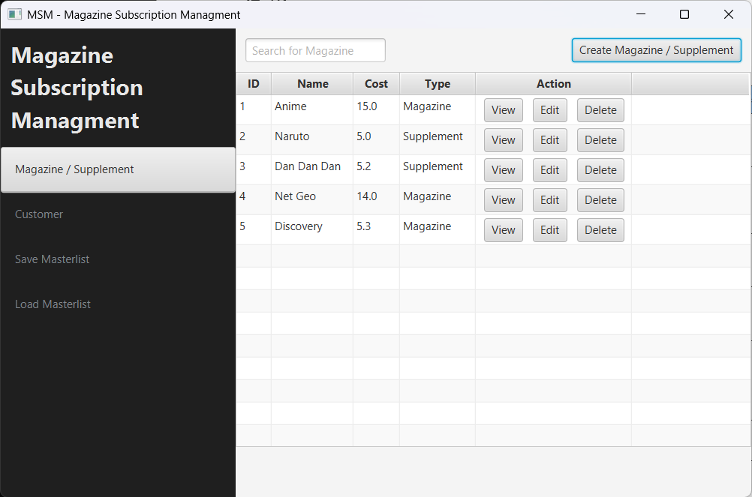

ID: P2
Description: Create a supplement called “Wild” with the cost of 2 and attach it to magazine “Discovery”
Expected Output: Supplement is created
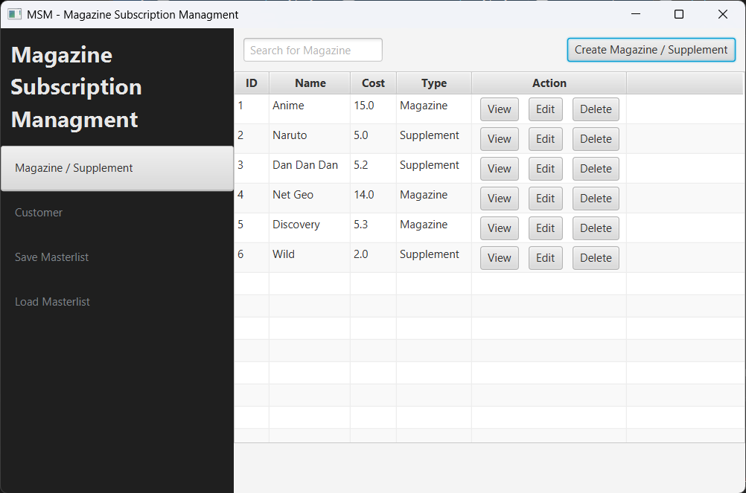

ID: P3
Description: View magazine called “anime”
Expected Output: A popup is opened with the field disabled for editing.
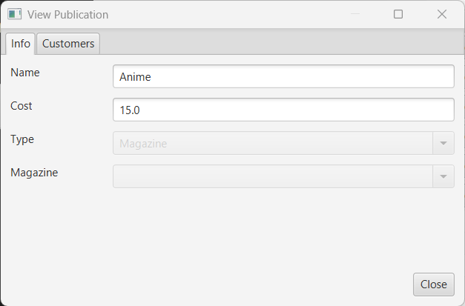

ID: P4
Description: Modify the name of the magazine “net geo” to “nat geo”
Expected Output: The name of the magazine “net geo” is modified.
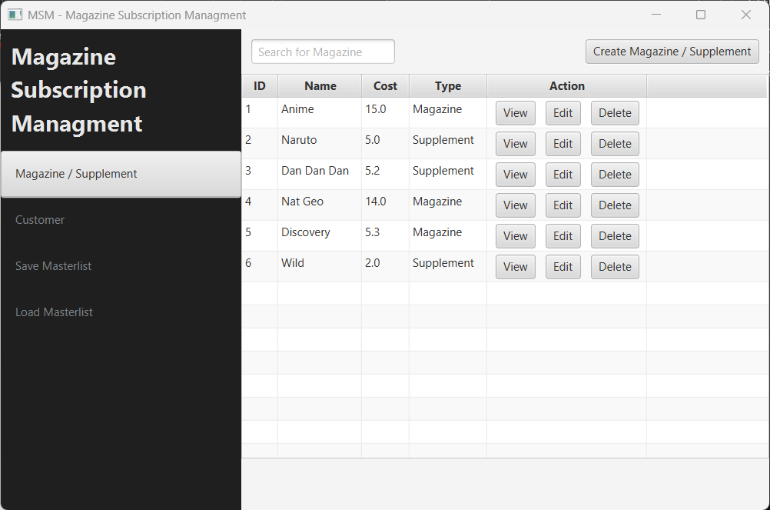

ID: P4_1
Description: View customer “John” subscription after modifying “net geo” magazine.
Expected Output: Magazine that is modified is updated inside customer subscription.
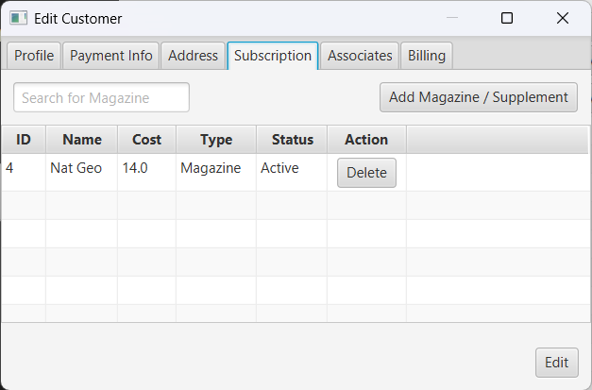

ID: P5
Description: Delete supplement “Naruto”.
Expected Output: Supplement called “Naruto” is deleted.
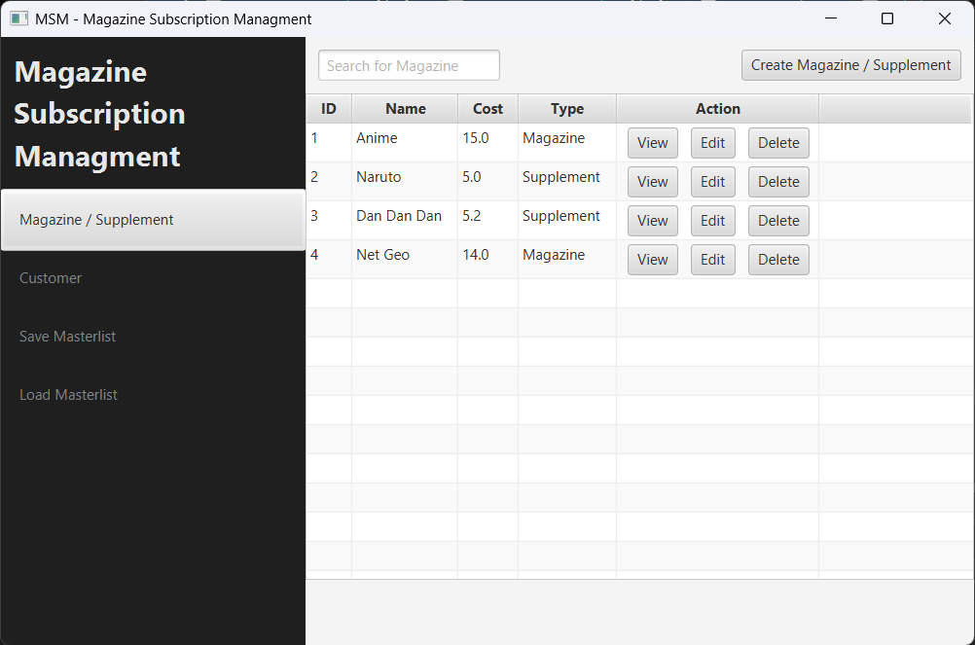
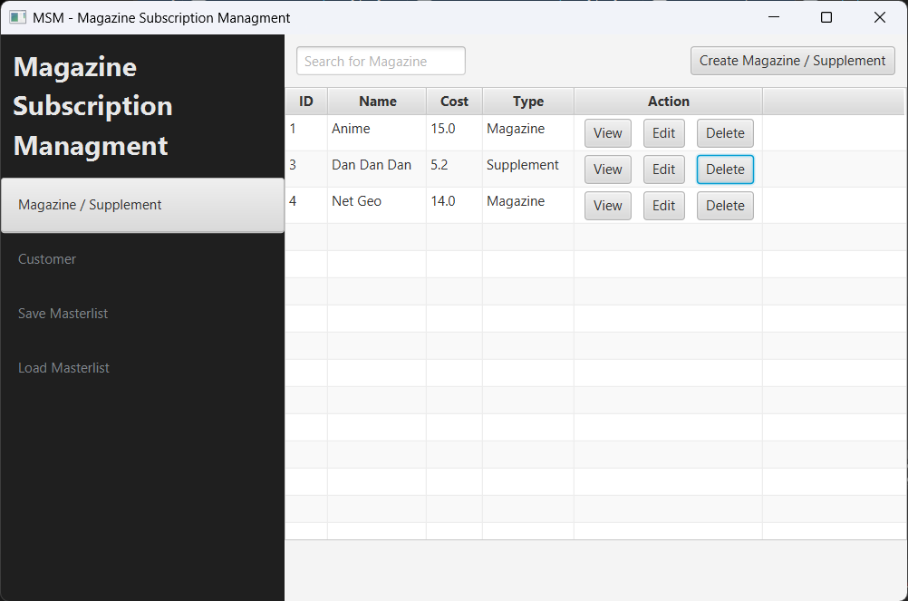
ID: P6
Description: Delete magazine “Anime”.
Expected Output: Magazine and supplements that links to “Anime” is deleted.
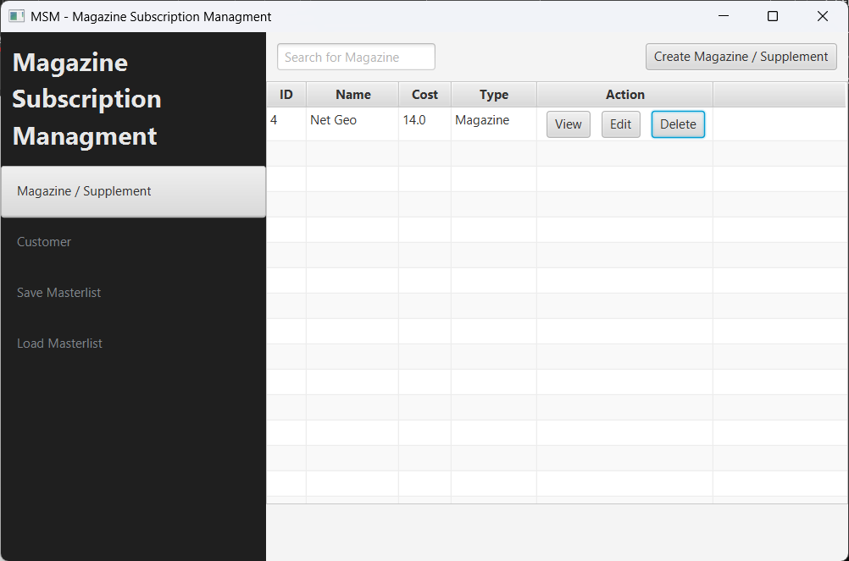

ID: P6_1
Description: View customer “Ashton Ketchum” subscription after deleting “Anime” magazine.
Expected Output: Magazine and supplements that links to “Anime” is deleted from customer subscription.
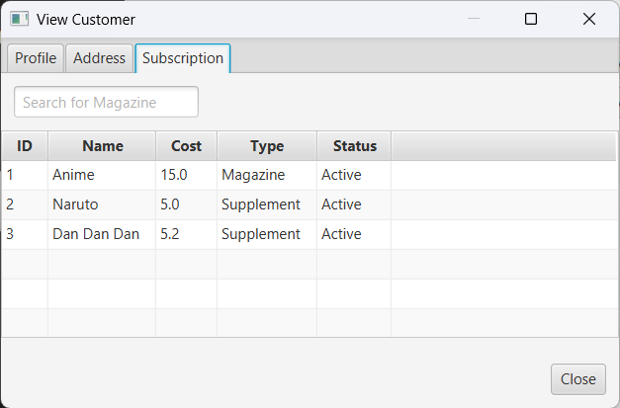
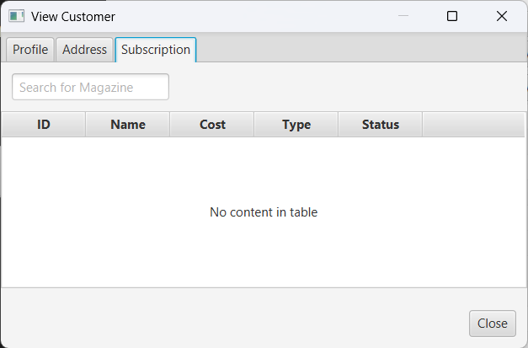

ID: P7
Description: Modify magazine “net geo” to “:@$”
Expected Output: Display an alert message “Name can only contain alpha-numeric characters, spacing, exclamation point, @ symbol, and hashtag”.
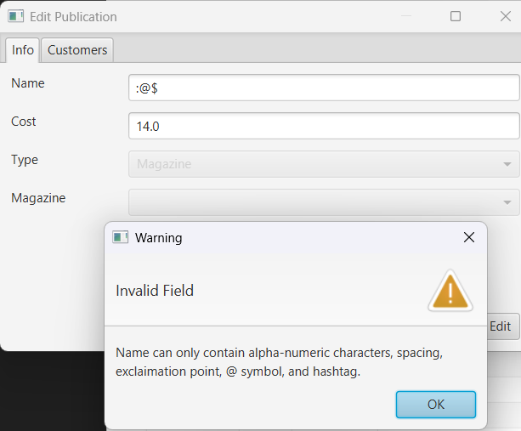

ID: P8
Description: Modify magazine “net geo” to “”
Expected Output: Display an alert message “Name can only contain alpha-numeric characters, spacing, exclamation point, @ symbol, and hashtag”.
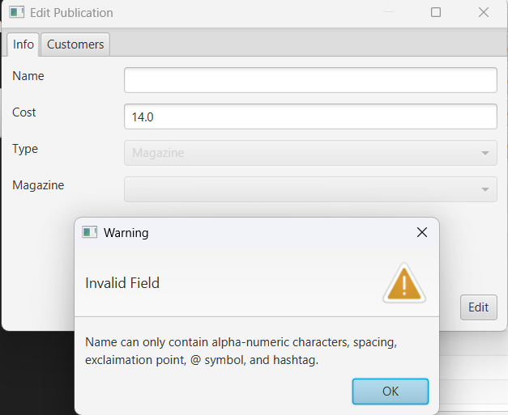

ID: P9
Description: Modify magazine “net geo” cost to -4
Expected Output: Display an alert message “cost cannot be negative or empty”.
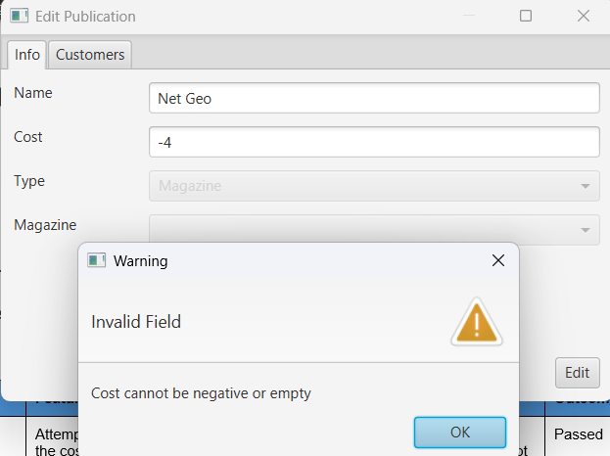

ID: P10
Description: Leave the magazine field empty.
Expected Output: Display an alert message “A magazine needs to be selected”
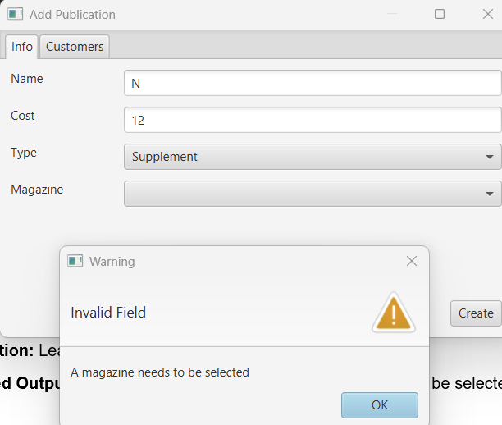

ID: C1
Description: Create a paying customer with the following data:
Name: “Albert”
Email: aleinstein@gmail.com
Payment Method: Credit Card
Card Number: 12345678
Street Number: 123
Postal Code: 123123
Street Name: one-north
Suburb: one-north.
Expected Output: Paying customer is created.
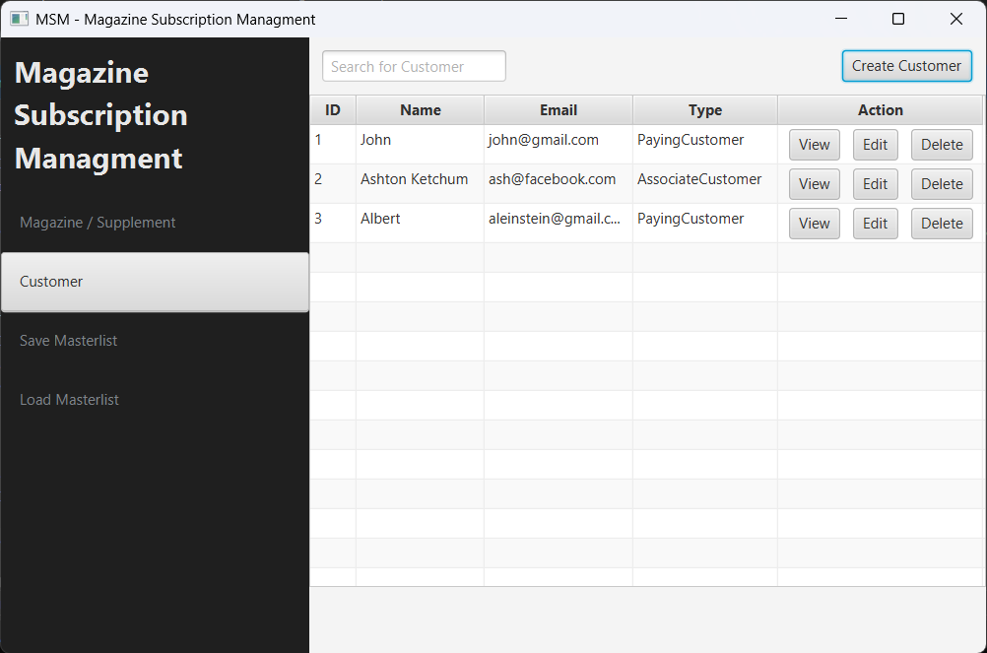

ID: C2
Description: Create an associate customer with the following data:
Name: Gabriel
Email: gab@gmail.com
Payer: Albert
Street Number: 321
Postal Code: 321321
Street Name: one-south
Suburb: one-south
Expected Output: Associate customer is created.
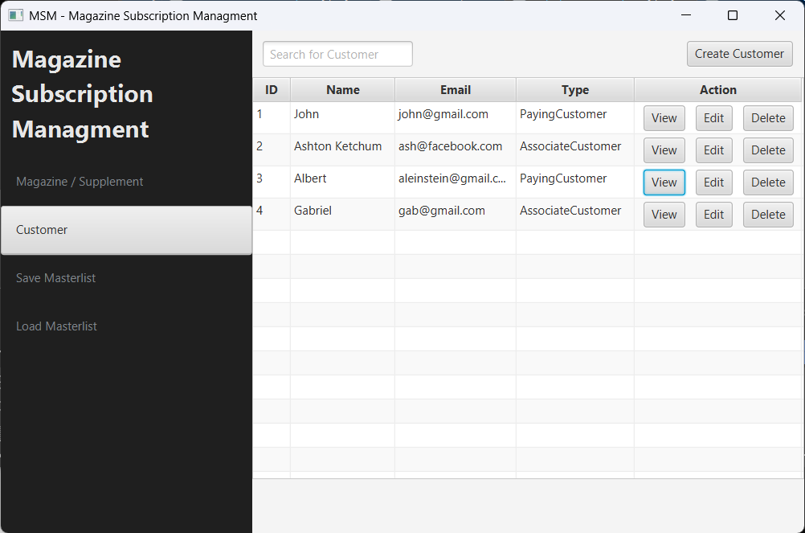

ID: C3
Description: View a customer called “John”
Expected Output: A popup is opened with the field disabled for editing.
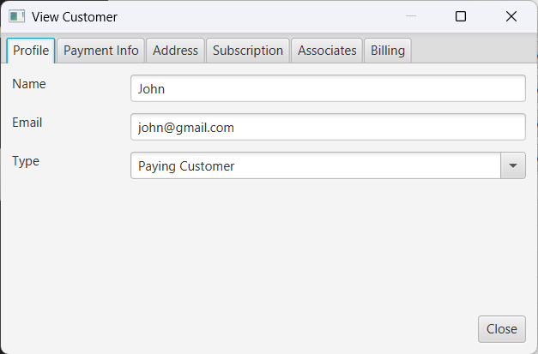

ID: C4
Description: Modify John’s email from john@gmail.com to john@yahoo.com Expected Output: Email changed from john@gmail.com to john@yahoo.com
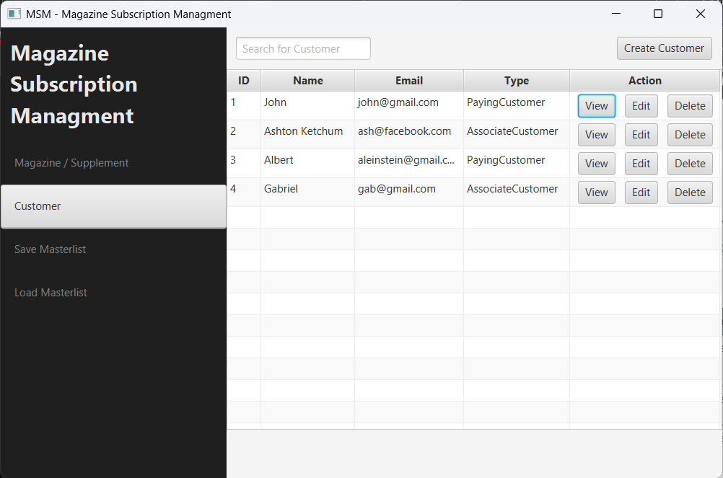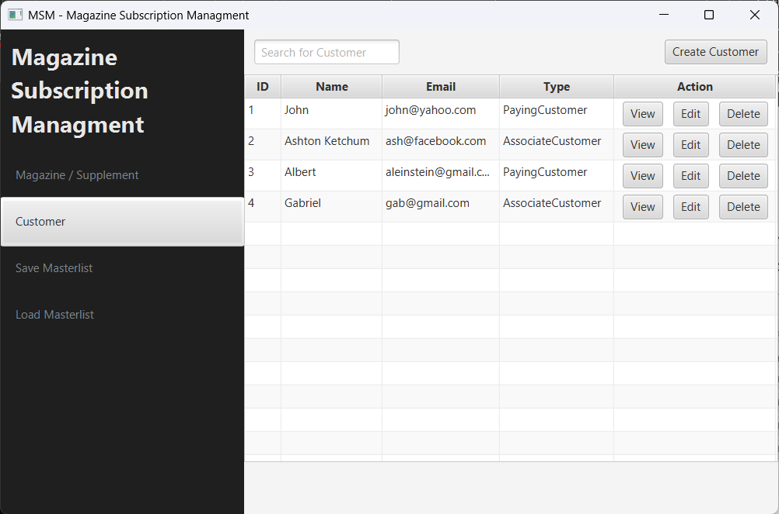
ID: C5
Description: Delete customer “John” from the system.
Expected Output: A paying customer called John is deleted.
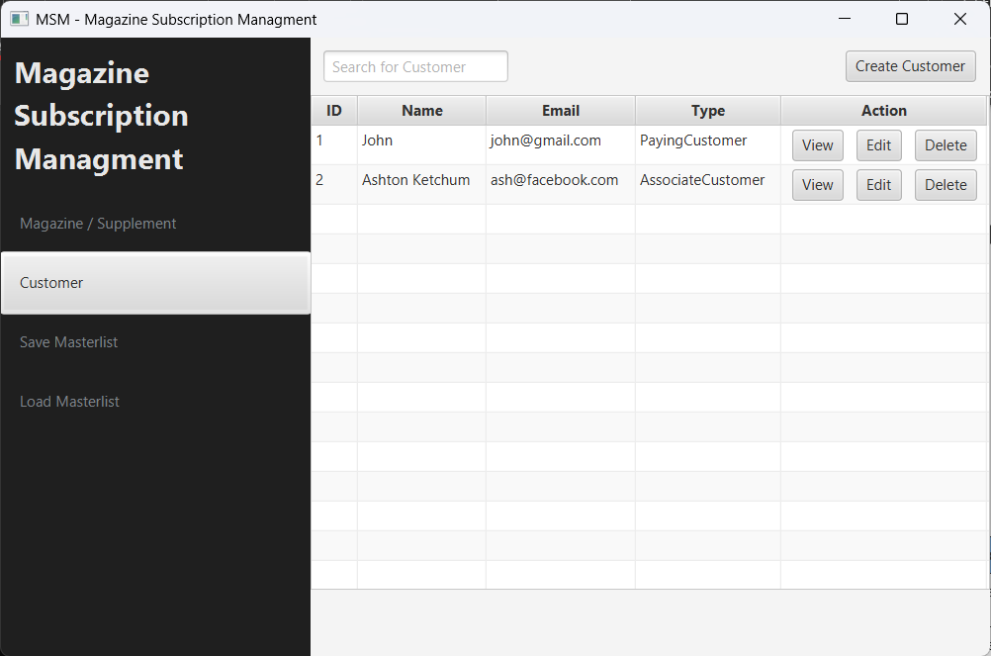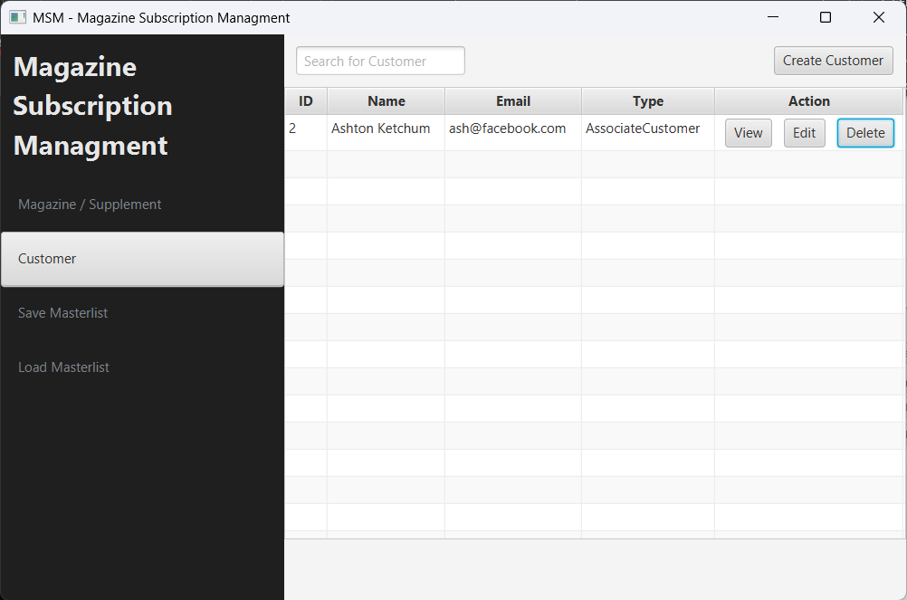
ID: C5_1
Description: View customer “Ashton Ketchum” payer and its current subscription status.
Expected Output: Payer is empty, and all subscription are inactive.
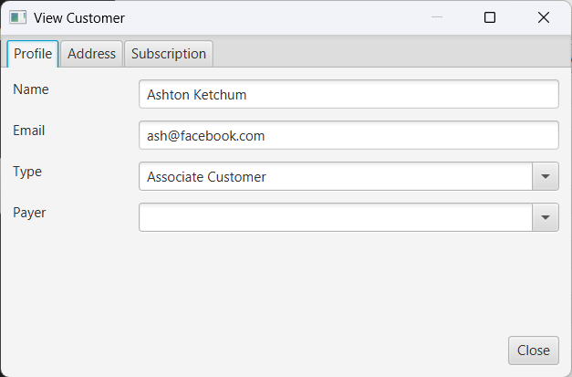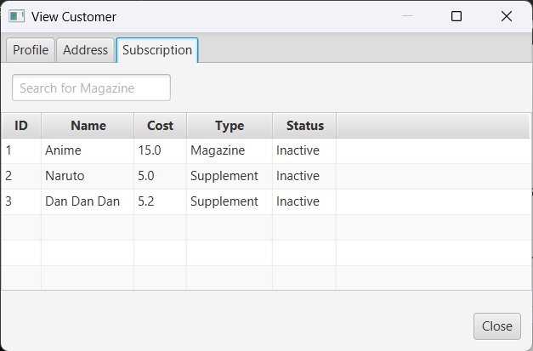

ID: C6
Description: Modify customer name “John” to “2425”
Expected Output: Display an alert message “Name can only contain alphabet, apostrophe, spaces, or hyphen characters and cannot be blank”.
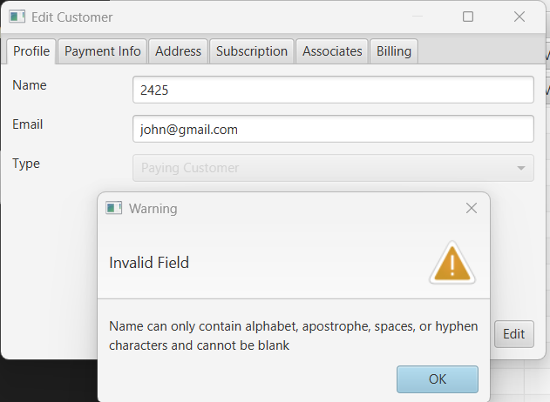

ID: C7
Description: Modify customer name “John” to “2425”
Expected Output: Display an alert message “Name can only contain alphabet, apostrophe, spaces, or hyphen characters and cannot be blank”.


ID: C8
Description: Leave card number field empty.
Expected Output: Display an alert message “Card number is empty”.
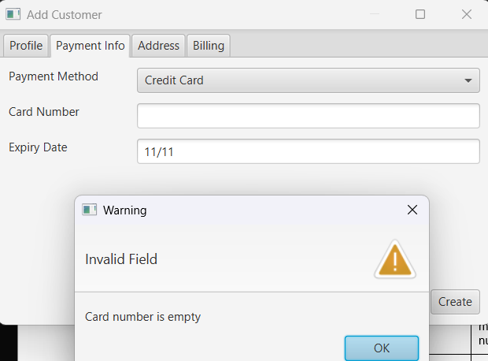

ID: C9
Description: Leave expiry field empty.
Expected Output: Display an alert message “Expiry date is empty”.
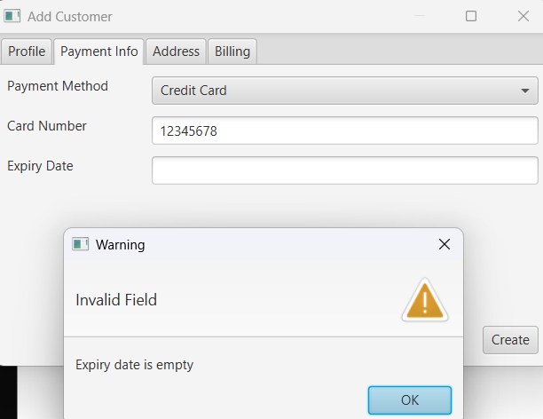

ID: C10
Description: Leave account number field empty.
Expected Output: Display an alert message “Account number is empty”.
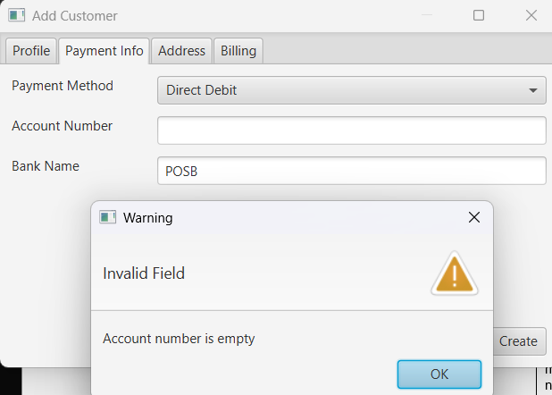

ID: C11
Description: Leave bank name field empty.
Expected Output: Display an alert message “Bank name is empty”.
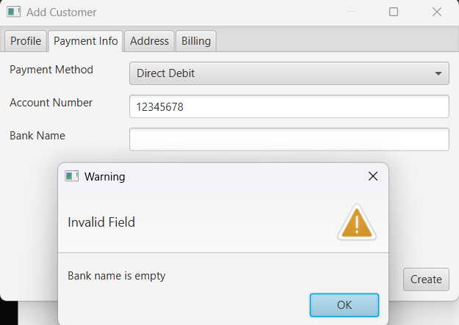

ID: C12
Description: Leave street number field empty.
Expected Output: Display an alert message “Street number must be a number”.
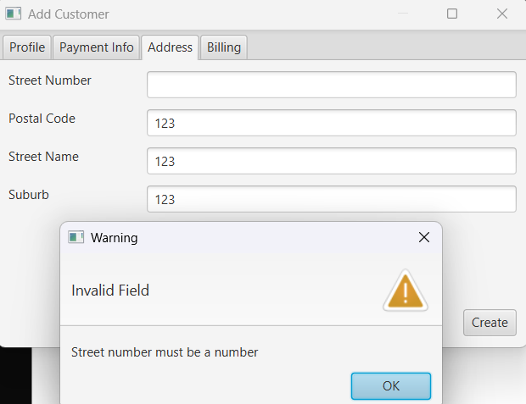

ID: C13
Description: Leave postal code field empty.
Expected Output: Display an alert message “Postal code must be a number”.
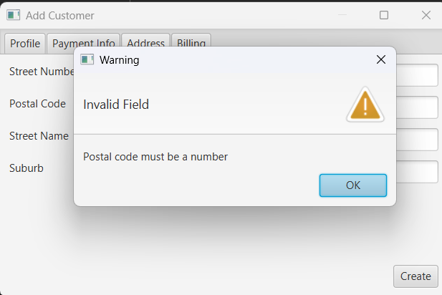

ID: C14
Description: Leave street name field empty.
Expected Output: Display an alert message “Street name is empty”.
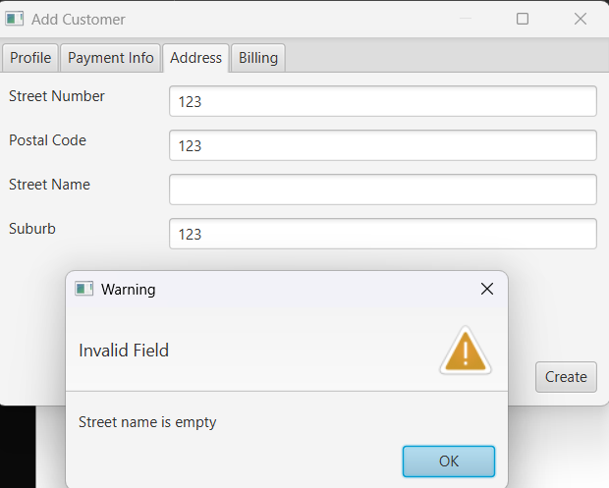

ID: C15
Description: Leave suburb field empty.
Expected Output: Display an alert message “Suburb is empty”.
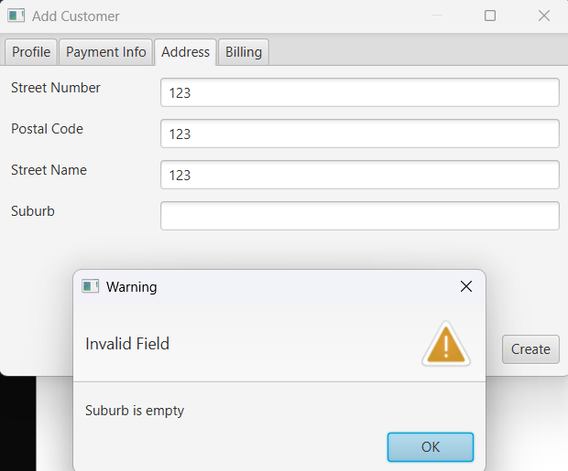

ID: C16
Description: Add “Anime” magazine and its supplement “Dan Dan Dan” to “John” subscription list.
Expected Output: A magazine and supplement is added.
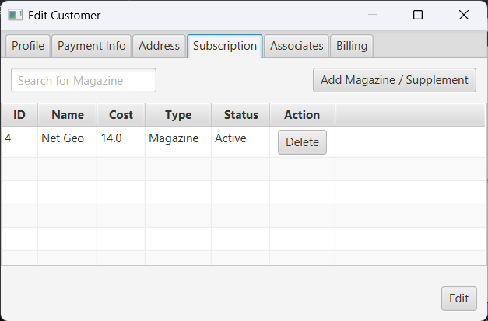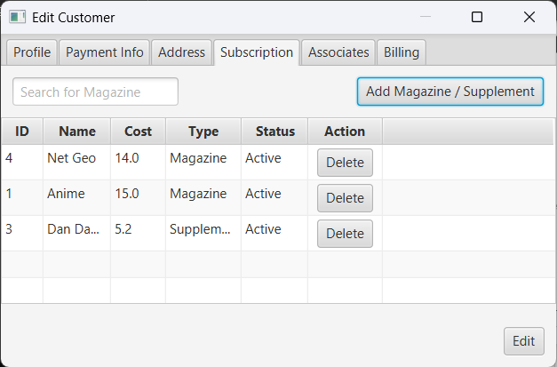

ID: C17
Description: Add “Anime” magazine to “John” subscription list.
Expected Output: A magazine and supplement is added.

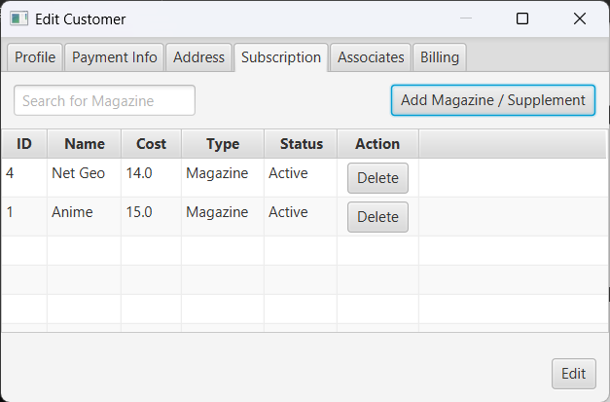

ID: C18
Description: Add “Anime” magazine to “Ashton Ketchum” subscription list.
Expected Output: The customer subscription list remains unchanged.
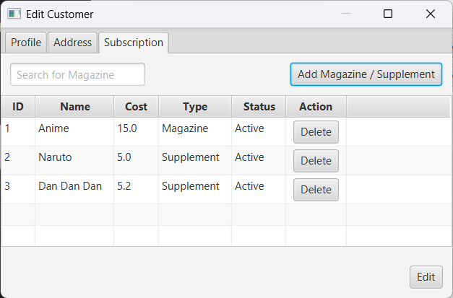

ID: C19
Description: Delete “Anime” magazine from “Ashton Ketchum” subscription list.
Expected Output: The magazine along with its supplements are deleted.
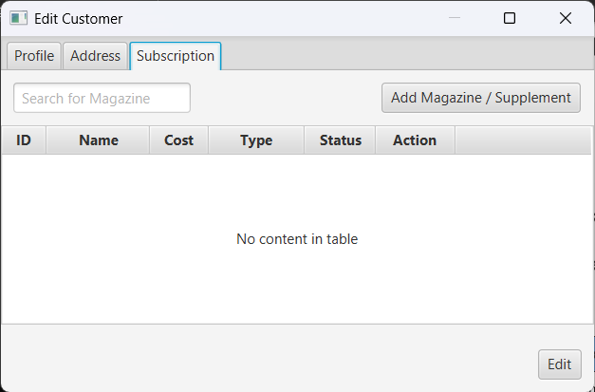

ID: C20
Description: Delete “Dan Dan Dan” from “Ashton Ketchum” subscription list.
Expected Output: The selected supplement is deleted.
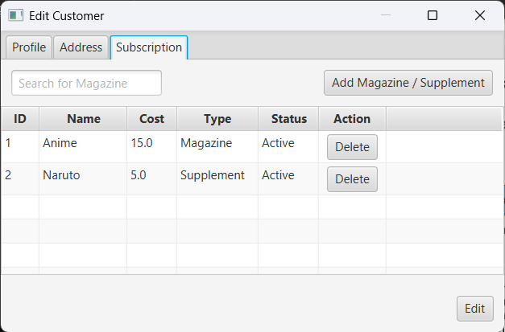

ID: C21
Description: Set “Ashton Ketchum” payer to empty.
Expected Output: The billing record and data for the associate customer “Ashton Ketchum” have been removed from the “Associates” and “Billing” tabs of the paying customer “John"
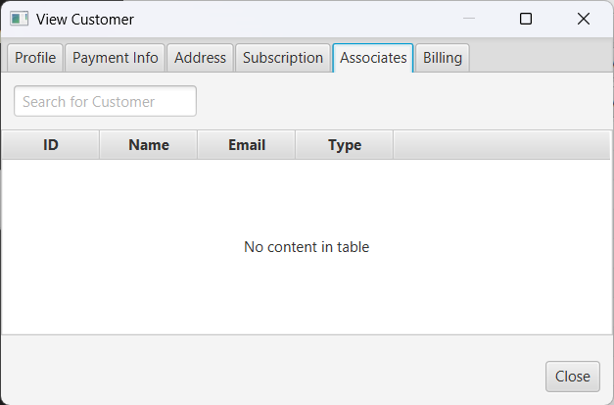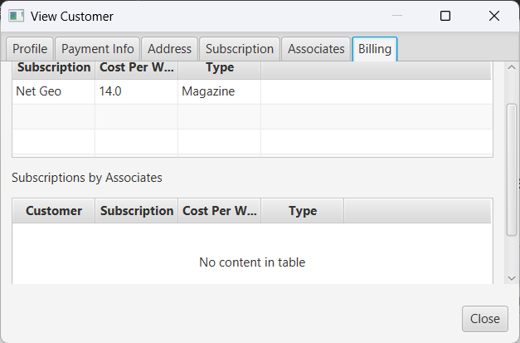

ID: ML1
Description: Click on “Save Masterlist” button.
Expected Output: A file containing the current data is saved.
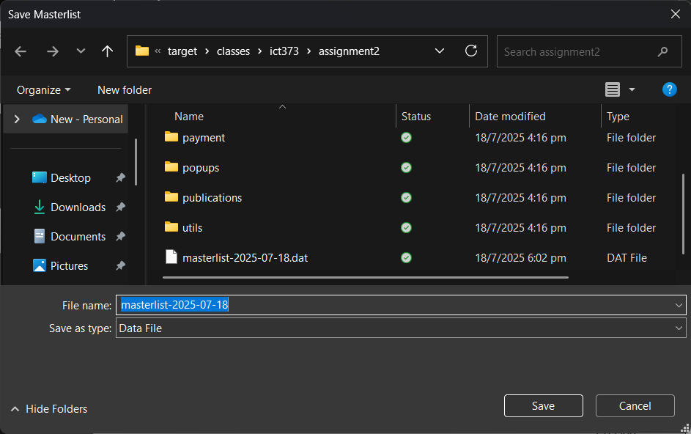

ID: ML2
Description: Click on “Load Masterlist” button.
Expected Output: Data is loaded into the program.
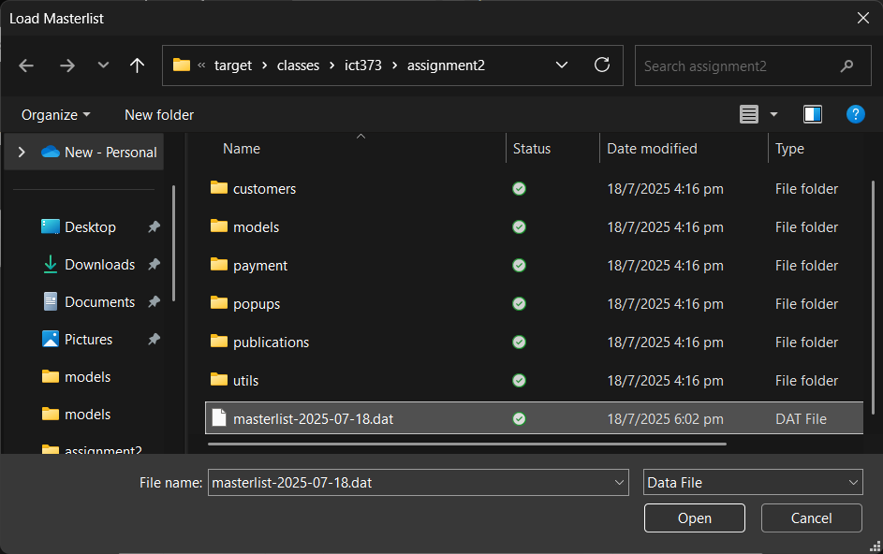

ID: ML3
Description: Click on “Load Masterlist” button and select a corrupt or empty data file.
Expected Output: Display an alert message “Failed to load masterlist from file”.
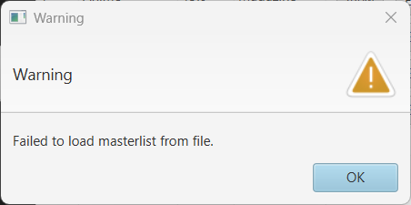

Hydration is a process of populating an object with data. Since the raw data lacks object references, it is replaced with hydrated ones, ensuring consistency and data uniformity.

